1.Modules to be implemented:

User Authentication and Submission Options
Anonymous or user-linked complaint creation.

Complaint Management
Category-wise input, priority selection, file uploads.

Status Tracking and Timeline
Track resolution stages and admin comments.

Escalation and Admin Panel
Escalate unresolved cases, admin assignment.

Reports and Analytics
Visual dashboards and CSV exports.

Week-wise module implementation and high-level requirements:

Milestone 1: Weeks 1–2
Module: Login and Complaint Input

Choose Public or Anonymous Mode:

  - Users can submit complaints anonymously or by logging into their account.
  - Anonymous complaints limit tracking but maintain user privacy.

Submit a Complaint with Optional Media:

  - Complaint form includes fields for category, description, and urgency.
  - Users can upload images or documents as supporting evidence.
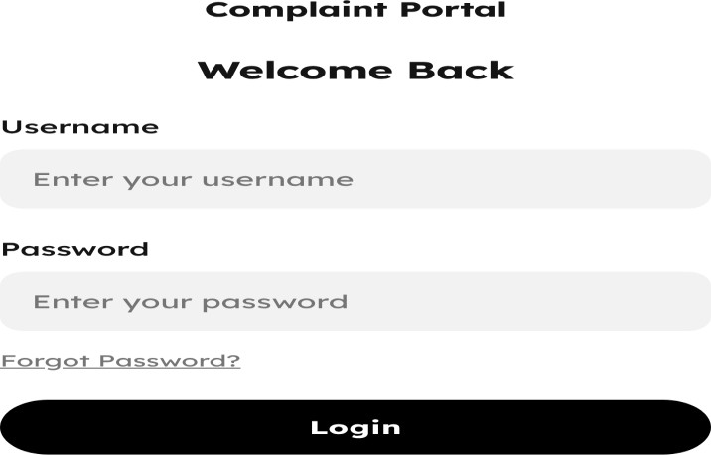

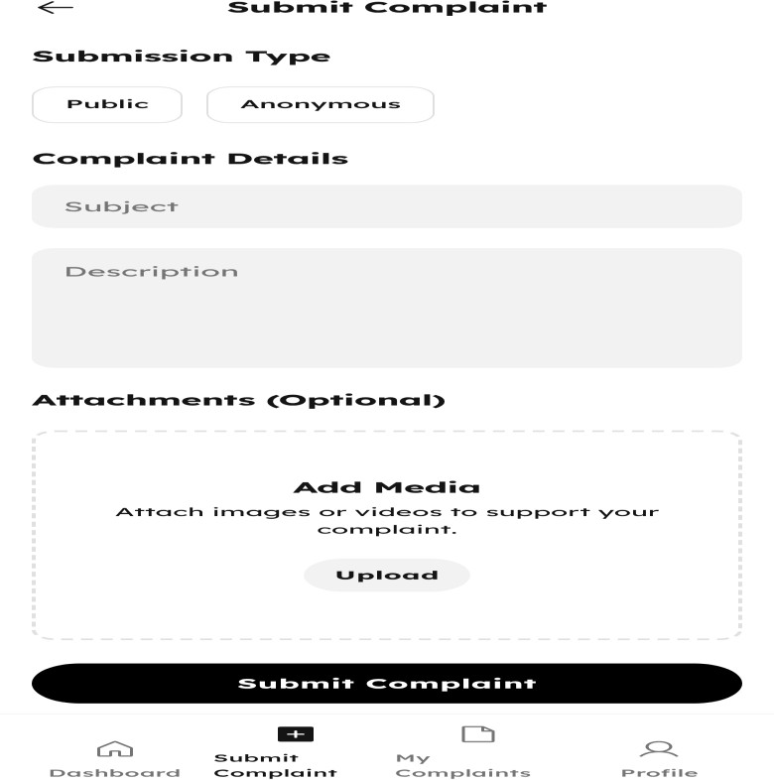

Milestone 2: Weeks 3–4
Module: Complaint Status System

Status: New → Under Review → Resolved:

  - Complaints follow a clear, trackable status flow.
  - Status changes are managed by admins based on progress.

Timeline of Updates:

  - Users can view a chronological log of all status changes.
  - Each update includes timestamps and admin comments (if any).

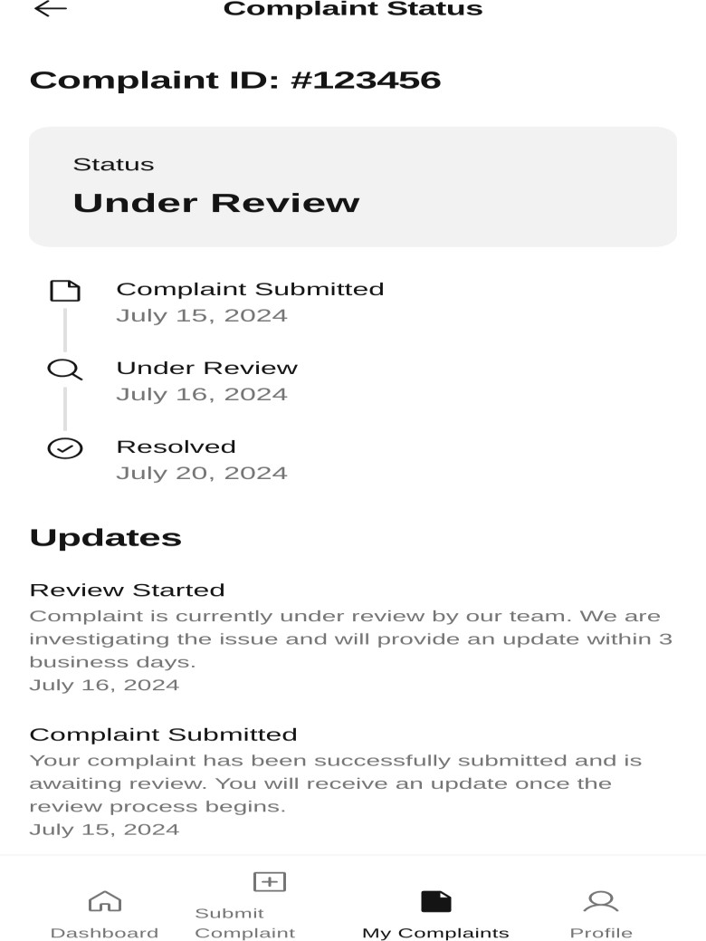

Milestone 3: Week 5
Module: Admin Dashboard

Assign, Update, Resolve Complaints:

  - Admins can assign complaints to staff and update their status.
  - Complaints can be marked as resolved once addressed.

Add Internal Notes and Reply to Users:

  - Admins can add private notes visible only to staff.
  - Public replies can be sent to inform users about progress.

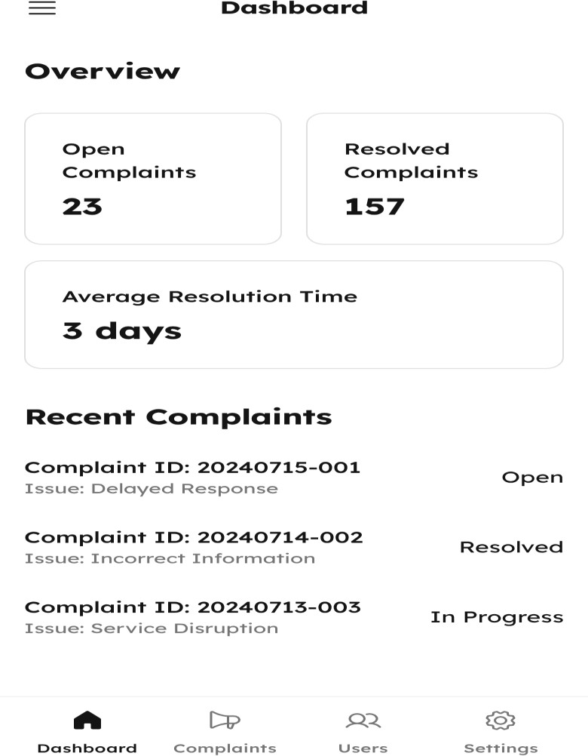

Milestone 4: Weeks 6–7
Module: Escalation Logic

Escalate Unresolved Complaints to Higher Authority:

  - Complaints that remain unresolved beyond a set time are escalated.
  - Escalated cases are forwarded to senior admins or designated authorities.

Notify Relevant Parties:

  - Users and responsible admins are notified of the escalation.
  - Notifications are sent via email or in-app alerts.

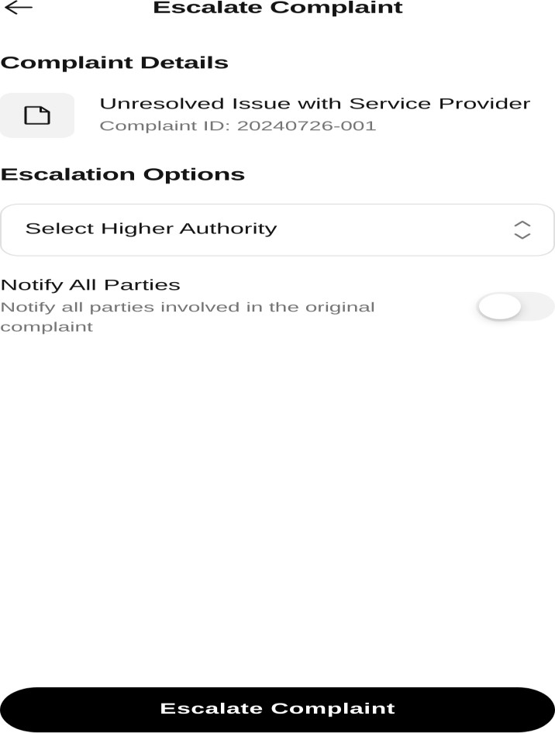

Milestone 5: Week 8
Module: Reports and Export

Generate Reports on Complaint Trends:

  - Visual dashboards show trends by category, status, and time.
  - Helps admins monitor performance and recurring issues.

Export Summaries in CSV/PDF:

  - Complaint data can be exported in CSV or PDF formats.
  - Useful for audits, reviews, and external reporting.

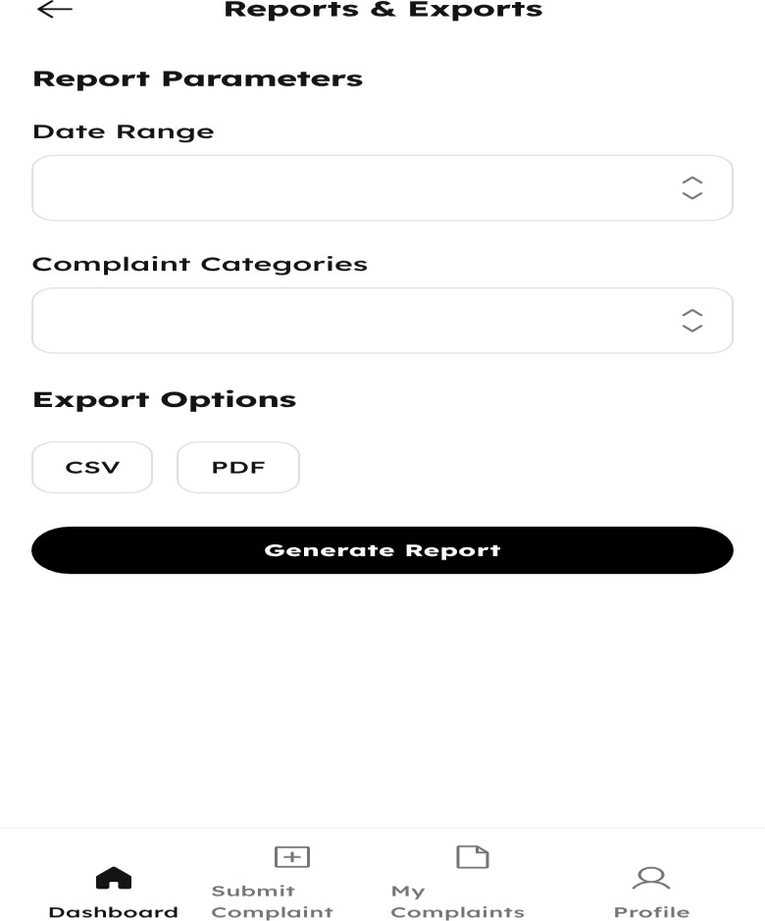

- Workflow diagram:
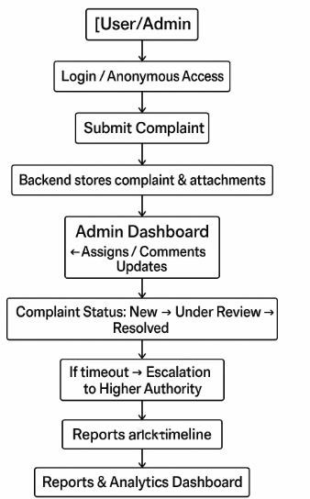

- Schema diagram:
